Exercise-1: Find missing elements

Write a function "missing_elements(my_list: list) -> list" that takes a

sorted list of integers and returns a list of missing integers in the range of the list.

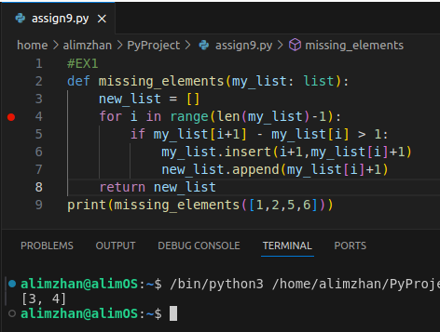

Exercise-2: Count occurrences

Write a function "count_occurrences(my_list: list) -> dict" that takes a list of integers and returns a dictionary where keys are unique integers from the list and values are their counts in the list.

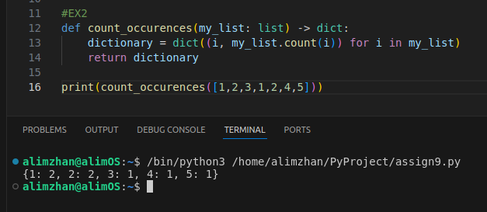

Exercise-4: Common elements

Write a function "common_elements(list1: list, list2: list) -> list" that takes two lists of integers and returns a list of unique common elements.

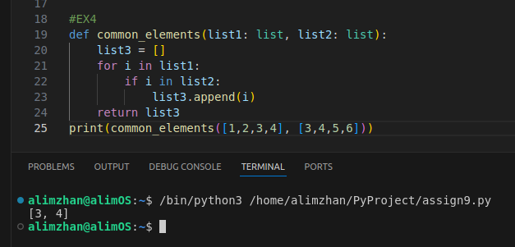

Exercise-5: Character frequency

Write a function "char_frequency(my_string: str) -> dict" that takes a string and returns a dictionary with the frequency of each character in the string.

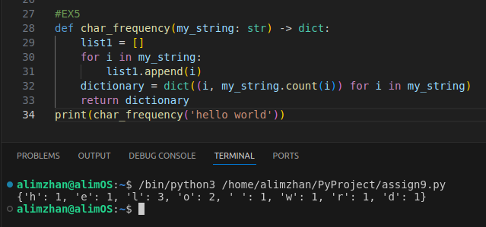

Exercise-6: Unique words

Write a function "unique_words(my_string: str) -> int" that takes a string and returns the number of unique words in the string.

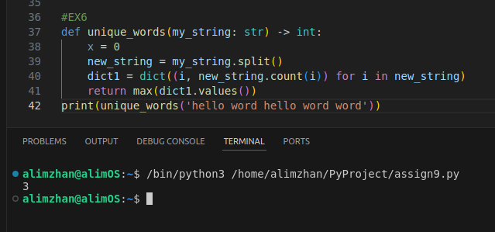

Exercise-7: Word frequency

Write a function "word_frequency(my_string: str) -> dict" that takes a string and returns a dictionary with the frequency of each word in the string.

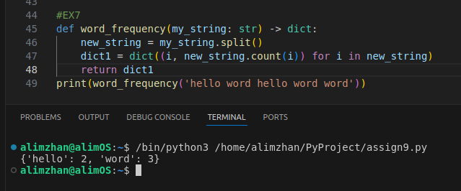

Exercise-9: Swap dictionary keys and values

Write a function "swap_dict(d: dict) -> dict" that takes a dictionary and returns a new dictionary where keys become values and values become keys. if you face duplicates, the first key should be saved.

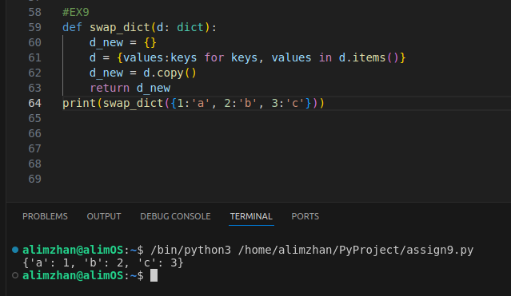

Exercise-10: Subset check

Write a function "is_subset(set1: set, set2: set) -> bool" that takes two sets and returns True if set2 is a subset of set1, and False otherwise.

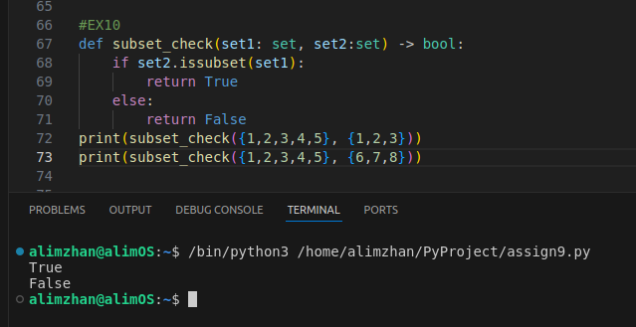

Exercise-11: Intersection of lists

Write a function "list_intersection(list1: list, list2: list) -> list" that takes two lists and returns a list of unique elements that are in both lists.

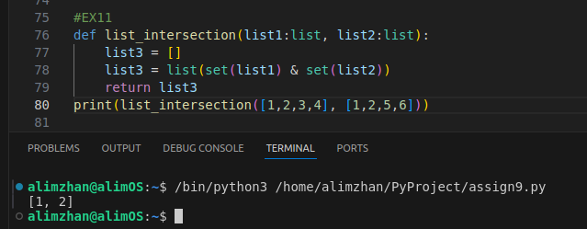

Exercise-12: Union of lists

Write a function "list_union(list1: list, list2: list) -> list" that takes two lists and returns a list of unique elements that are in either of the lists.

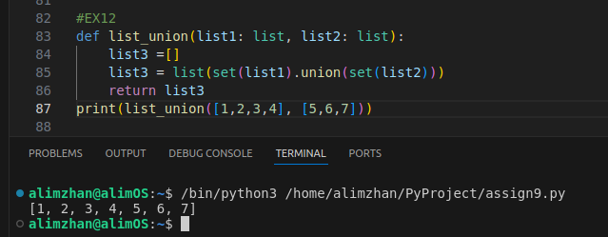

Exercise-13: Most frequent element

Write a function "most_frequent(my_list: list) -> int" that takes a list of integers and returns the most frequent element in the list.

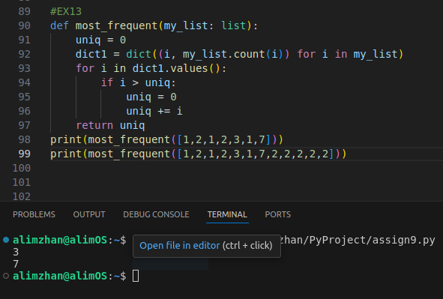

Exercise-14: Least frequent element

Write a function "least_frequent(my_list: list) -> int" that takes a list of integers and returns the least frequent element in the list.

